Derek Mauriello
Professor Baldassano
Art History 101
June 20, 2013
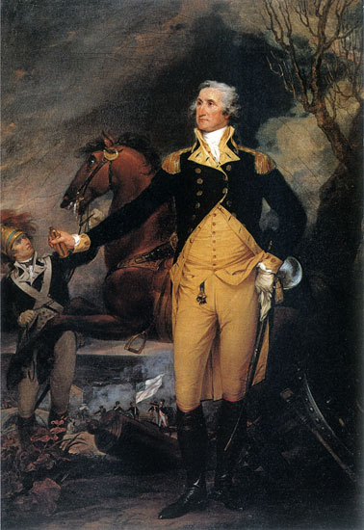
Analysis of “General George Washington Before The Battle of Trenton” by John Trumbull”

This analysis will discuss the elements of art and design in one of the most famous paintings by John Trumbull, America’s first famous artist. The painting is a portrait of George Washington titled “General George Washington Before The Battle of Trenton”. This beautiful portrait is housed at the Yale University Art Gallery in New Haven, Connecticut. It was presented as a gift to the Yale Art Gallery by the Society of the Cincinnati in Connecticut, of which John Trumbull was a member. The accession number is 1806.1. John Trumbull painted this portrait in the year 1792 in Philadelphia, which was then the capital of the country at the time. The medium of the painting is oil on canvas. The portrait measures two hundred and thirty-five cementers by one hundred and sixty cementers.
According to the description of the painting at the Art Gallery, in 1792 the city of Charleston, South Carolina, was looking for an artist to paint a portrait of George Washington for City Hall. They desired a portrait of this heroic man, however, the color and background was to be left up to the artist who was commissioned to paint the portrait. Trumbull stepped forward and offered to paint this portrait. Since John Trumbull was a close friend of George Washington and served under him in the Revolutionary War, he was honored to perform this task. He wanted to characterize the supreme importance of Washington during the Revolutionary War. In order to show the importance of Washington, Trumbull felt having the portrait take place during the Battle of Trenton would do just that. In Trumbull’s opinion, the Battle of Trenton was Washington’s first major victory and the first major turning point in the war.
Trumbull and Washington discussed the scene, mood, danger, and the desperation he was trying to convey in the painting. The description at the Gallery said Trumbull looked at the scene again, and he happily transferred to the canvass, the lofty expression of his animated countenance, the high resolve to conquer or to perish. It also stated whether inspired by the renowned ancient Greek sculpture Apollo Belvedere or by a more ordinary statute of an orator, Washington's stance and gesture suggests the "noble grandeur" associated with classical sculpture in the late 18th century. Surprisingly, the city of Charleston decided that the portrait was not the type of portrait of Washington they had in mind. They complained it was more of a historical painting rather then a peacetime image of the man. Trumbull agreed to paint another portrait of Washington that is more to the city’s liking and he will keep, in his opinion, the best painting that exists, for him.
When looking at this painting you can observe how the lines clearly outline both the shape of Washington’s heroic figure as well as his clothing. You see his choler button down to form that V shape angle of his coat. The bottom portion of his jacket forms a perfect upside down V, which was typically how military officers wore their officer coats at the time. His left arm is down resting on his sword. His right arm is extended out holding a looking glass. A good observer will notice his left hand has a glove on it while his right hand does not. What that signifies, I am not sure. At the same time it appears his right arm is skinner then his left.
Trumbull’s excellent use of lines perfectly shows the eyelids to the eyebrows. This is beneficial because it helps to add to the feeling your looking at an exact replica of the man. There is also astonishing definition to Washington’s body. You clearly see the muscle outlined in his legs, stomach, and arms. This also enhances the idea that you are looking at the real person. The horse directly behind Washington has the same excellent definition. The muscles are clearly present on the horse’s legs and neck. Personally, I feel this is advantageous, as you need that to help give a more life like quality to the whole painting. Otherwise it is just a flat canvas with paint on it. The brightness of the colors of Washington may distract the viewer from noticing the soldier trying to control the horse and the battle going on in the lower portion of the painting. Trumbull wanted this painting to show the complexity of the heroic figure of Washington, which is probably why he chose to portray the man himself with bright colors. Trumbull wanted to make him stand out in front of the painting so therefore, everything in the background was drawn with darker colors so they would be muted in the background.
Trumbull’s contrast between the light and dark colors is beautifully blended. His use of coloring for the sky lends itself to Washington’s courageous image. The darker colors in the background help display the horror of the war and the struggles Washington had to suffer in order to obtain victory. You can undoubtedly notice the spacing between Washington, the soldier holding his horse, and the battle itself. It helps give value to the painting. Value in that Washington was a warrior. It showed he was not hiding behind all his men but rather up front fighting along side them. The broken cannon beside Washington, I feel, gives credit to this theory. The fact that the cannon is broken obviously shows that there is a battle raging and Washington standing right next to it clearly portrays he is in the thick of it. The scale of the painting may not be that accurate. I feel the size of Washington compared to his horse isn’t correct. Washington seems to be much bigger than the horse. Then again, Washington is supposed to be the heroic, larger than life figure, in which case the scale is justified. Washington was known as a tall man for this period of time in history. Perhaps, that is why he appears bigger than the horse, simply to show his lofty self.
Understanding the elements and principles of design used in creating this portrait truly assists the viewer to appreciate the man that George Washington was, as well as what he experienced. I am familiar with American history and because of that, I feel I have the knowledge to understand why Washington stands out as a warrior in this painting. Another person would probably just look at it and say it’s just simply a picture of Washington. If a person were to actually take the time and look closely at the painting, they will see more then just the man. They will discover who he was, what made him great, and why he was a warrior. The portrait displays his stregthe and determination by its boldness and attention to detail. Take a moment and adsorb what you are looking at in order to understand what you are really looking at. Modern day cameras or iPhones would not have been able to capture a scene like this. What this portrait of Washington must of meant to John Trumbull, I cannot imagine. I do know he treasured it because he stated “this is the best portrait of George Washington during his military career that exists”.

