James Doran
Professor Baldassano
Art History 101
May 25, 2018
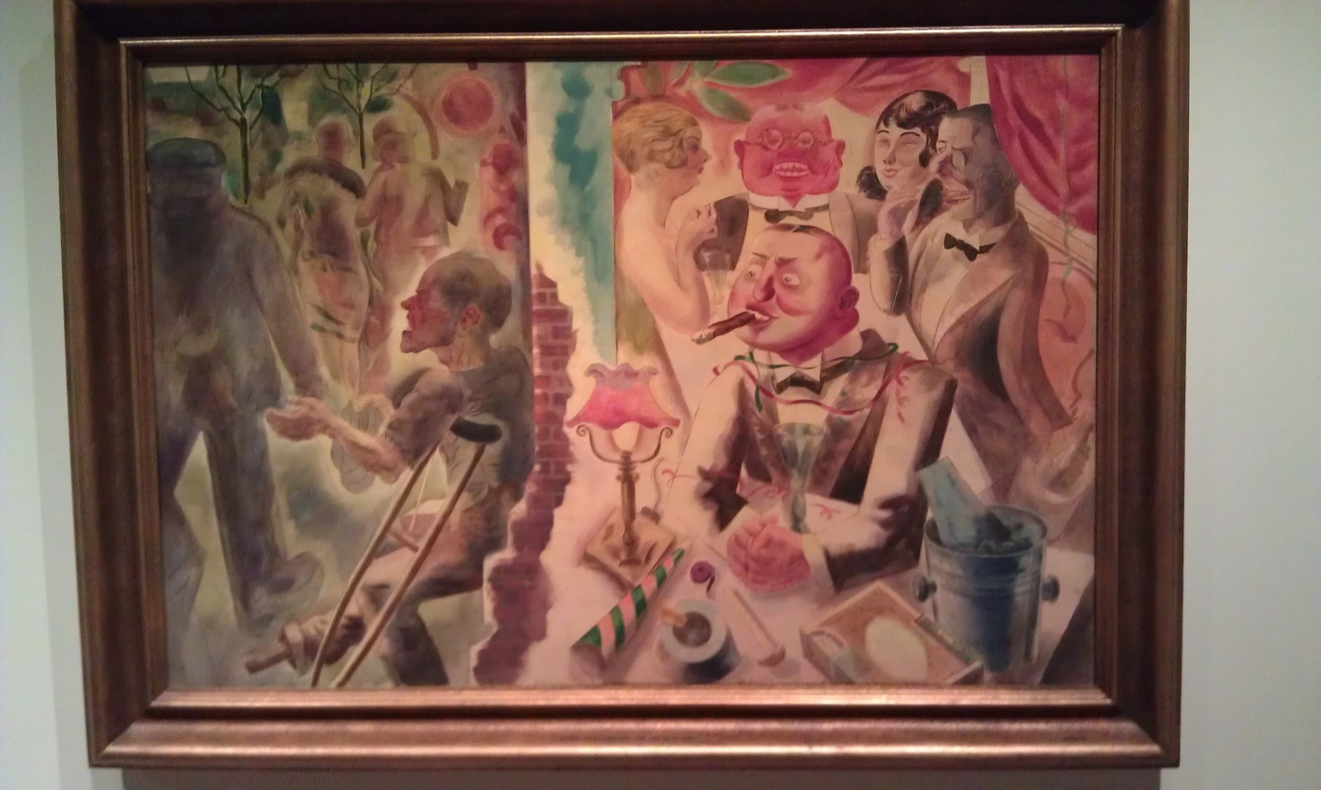
The artwork on which I chose to do my reaction paper is “Drinnen und Draussen (Inside and Outside)” by George Grosz (1893-1959), painted in 1926. The accession number is ILE1981.9.12 and it is housed in the Yale University Art Gallery in New Haven, Connecticut. The measurements of this painting are approximately 31 ½ by 47 inches and its object type is oil on canvas.
On my first visit to the Yale University Art Museum, I was looking for an artwork that I could understand and “relate to”, since I have very little art appreciation experience. I was searching for Van Gogh’s “The Night Café” because I found it appealing during a class trip just two days prior when George Grosz’s painting caught my eye. What I immediately noticed in “Drinnen und Draussen” were two totally different realms being portrayed by the artist on the one piece of canvas. I observed that these two worlds were being separated by a solid barrier that kept both worlds and its inhabitants from acknowledging and interacting with the other. On the right side of this painting, five individuals are being portrayed as having a good time in a party atmosphere. All of them are smiling with drinks either in their hands or directly in front of them. All of the subjects on the right are well dressed and seem to be well fed based on the roundness in their faces. When I turned my attention to the left side of the painting, I noticed a crippled man begging on the street and being ignored by people passing him by. He is the only person on the left side that has noticeable facial features. All the other people are faceless and their bodies are blurry and they have their backs turned as they are walking away from the begging crippled man.
The artist makes a point of defining the facial features of all the characters on the right side while only one character on the left has his face shown with any detail. There are three others on the left but are painted with no defining features. I became very interested in this artwork and decided that I’ll have to make another visit to the art gallery because I’ll need more time to absorb everything that was going on in this painting.
On my second visit to Yale’s Art Gallery I brought a chair to place in front of Drinnen und Draussen in order to spend some quality time with George Grosz’s work. I spent almost an hour admiring this painting and began drawing a thumbnail sketch to help me see more details in the painting that I didn’t see on my first visit. The colors in this painting appeared to be softer than I would expect of an oil painting. Compared to other oil art works nearby, the colors seamed to be similar to a pastel, something I would associate with a water colors artwork. There was a lot of the color red being used, showing a warm comfortable environment, on the right side of the painting which shows a party scene for the prosperous higher class. Two of the men in the celebration scene on the right had very fat facial structures with an abnormal amount of red which made me think of someone who was drinking too much, while the crippled beggar on the left had sharp, thin facial features most likely due to living a much harder life and obviously eating less than his counter parts on the right. Even the wall that separated the two worlds has soft pleasant blue tones facing the partiers and a rough outer brick layer facing the world on the left. At first I thought I was looking at two different worlds and the inhabitants of each, but upon further examination I saw on the left side of the painting what looked like another well-dressed couple walking away from the beggar as if they just left the party characterized on the right side of the painting. I determined that this couple must have been part of the individuals from the party scene because I recognized what looked like a mink-like stole around the woman’s neck and a fancy derby type hat on the gentleman. These types of clothing would not be part of a poor person’s wardrobe and I recognized the man in the derby hat was waving off the beggar with his right hand without making any eye contact. There was one more person on the left side of Grosz’s work who wore a heavy coat and his entire form was painted in different shades of grey to add to the cold and heartless environment that the beggar lives in. Even this somewhat large man was faceless to augment the loneliness I began to feel for the crippled character.
Even the trees outside were almost bare of leaves to show that winter is on its way and the beggar is left out in the cold. The “outside” world represents the desolate lower class while the “inside” world represents the wealthy upper class. As the large greyish figure passes the cripple outside leaving him alone in the cold heartless world while the rich and powerful continue to celebrate their world of over indulgence that includes champagne, cigars, and party favors.
After carefully examining George Grosz’s painting I read a plaque next to the painting that gave some background on Grosz and the painting which presents the stark disparity between the rich and poor in Berlin Germany after the First World War. This now tells me that the cripple on the left is a war veteran who most likely lost his leg in the war only to be ignored by the “grotesque newly rich” as they over indulge and pamper themselves while having a great time in a club.
Although this painting was done almost 90 years ago, I think it’s safe to say that even today, this scene is being played out across America nightly. As an unemployed Veteran, I myself can relate to the wounded beggar being represented in “Drinnen und Draussen”. I get easily offended when I see today’s “upper class” enjoying their wealth as I struggle daily trying to maintain a living during these hard economic times. I get depressed when I think of the years of my life that I gave to defend this country and provide a safe environment for those around me, only to feel left out in the cold and dealing with the harsh realities of life, much like crippled character. Because of my feelings, George Grosz’s painting speaks to me on an emotional level that was unexpected when I started this project. This painting shows the starkest contrast between rich and poor that I’ve seen in a great while.

